BSAN 450 Assignment 11

1) In each part of this problem the ACF and the PACF of a time series are plotted. For each part identify the model based upon these two graphs. The seasonal period is 12.

a) ACF

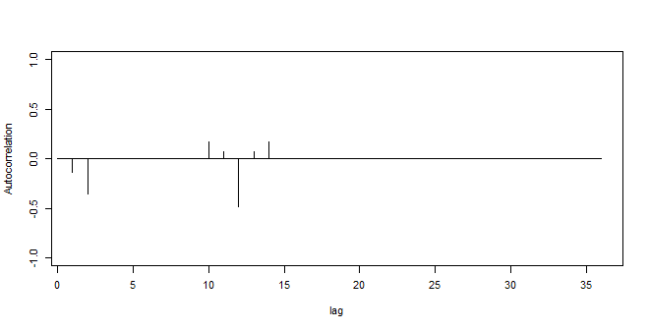

PACF

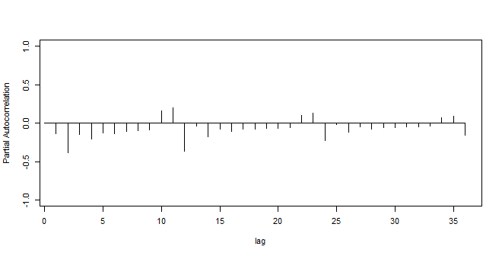

MA(2)\*SMA(1) because ACF tapers off after 2 lag and then only appears at 0 and 12 but not after.

b) ACF

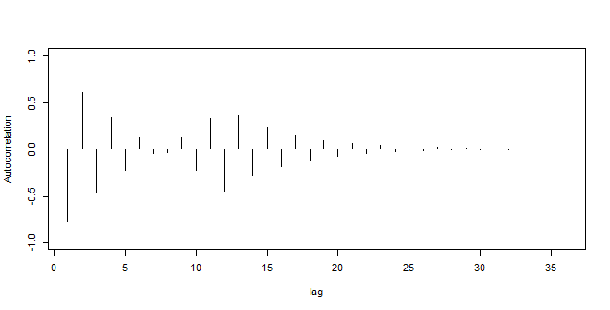

PACF

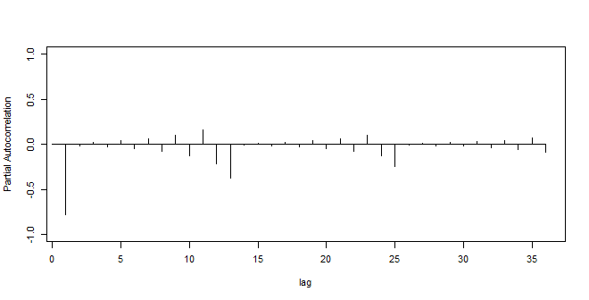

AR(1)\*SMA(1) the PACF tapers off after lag one and the pattern occurs at 12 and then not after.

c) ACF

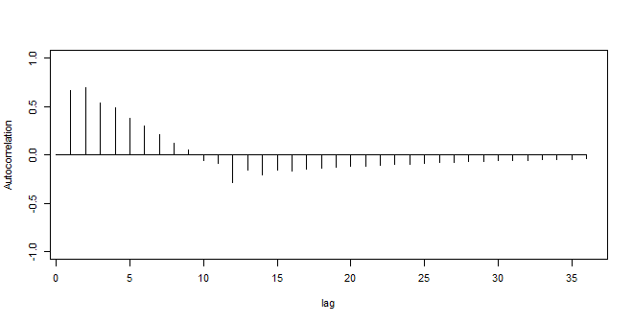

PACF

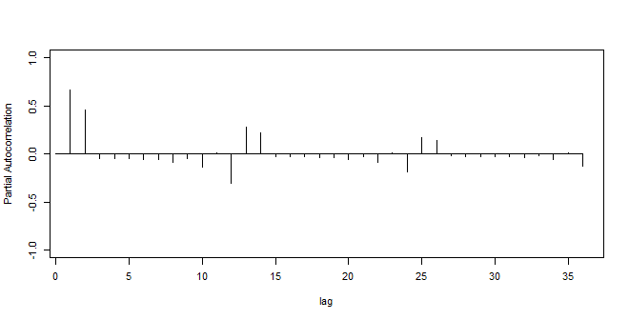

AR(2)\*SAR(2) It first appears to taper off after 2 lags and then the patter repeats at the 12, 24 mark and is largely tapered off by the 36 mark on the PACF graph.

d) ACF

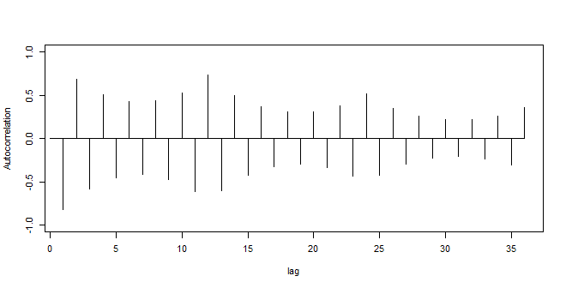

PACF

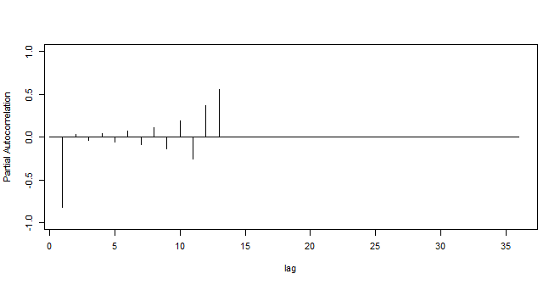

AR(1)\*SAR(1) it first tapers off after 1 lag and then appears again at the 12 mark but not after on PACF graph

e) ACF

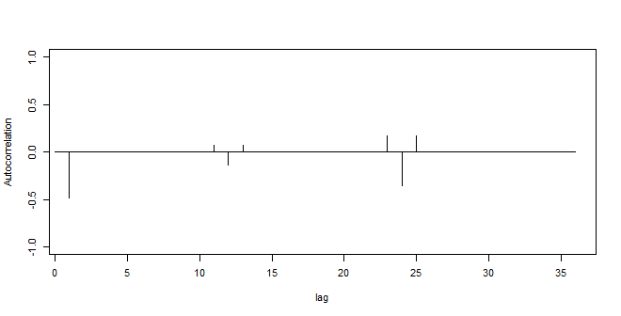

PACF

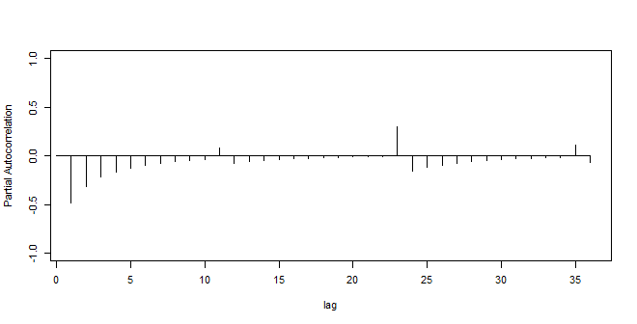

MA(1)\*SMA(2) it tapers off after one lag and then repeats again at the 12 and 24 mark on the ACF graph

f) ACF

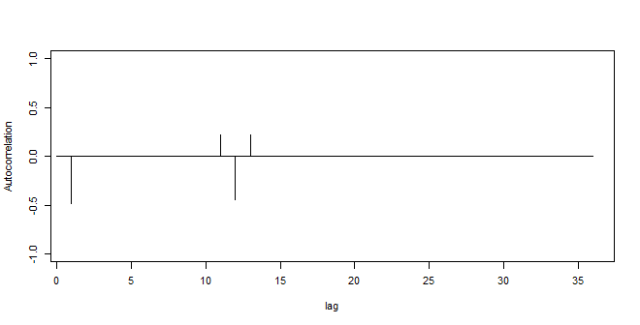

PACF

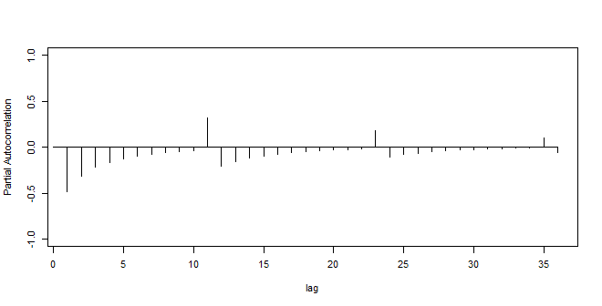

MA(1)\*SMA(1) or MA(1)\*SAR(3). I would test both of these models because the ACF tapers off after one lag but then the pattern repeats at the 12 lag on the ACF and the 12, 24, and 36 lag on the PACF.

2a) The following is a time series plot of a seasonal time series and the sample ACF for this time series. Is this process stationary? Justify your answer.

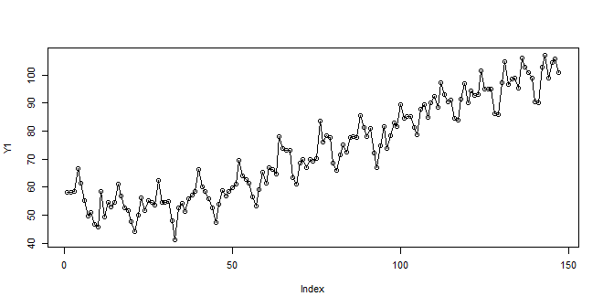

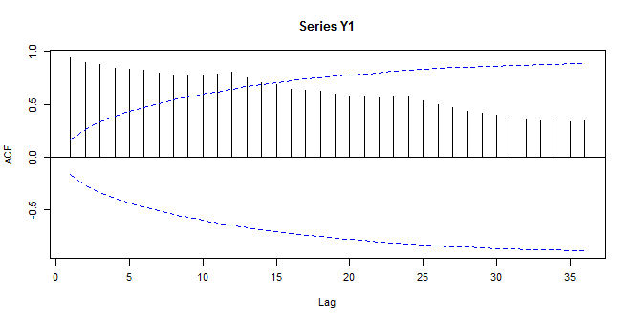

No, this series is not stationary because the mean of the data is increasing.

b) The following is a time series plot of the first difference of this time series and the sample ACF of the first difference. Is the first difference stationary? Justify your answer.

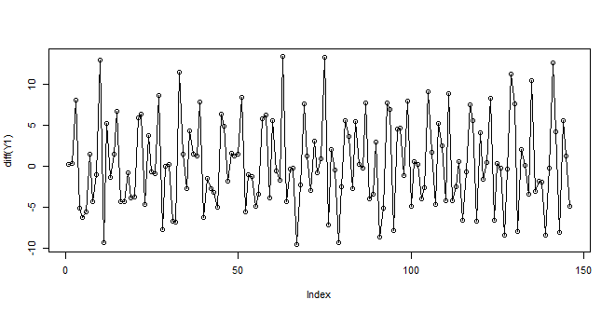

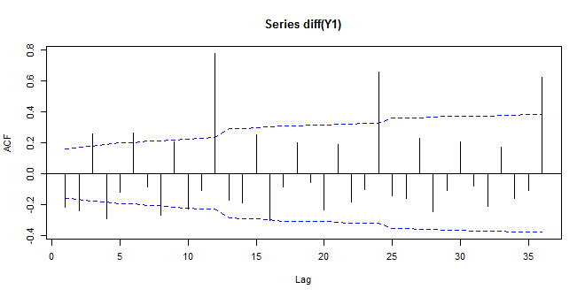

The difference of the series looks stationary. The mean looks constant and the variance looks ok. There are some ACF values that are significantly large at the 12, 24, and 36 lags.

c) The following is a time series plot of the twelfth difference of this time series and the sample ACF of the twelfth difference. Is the twelfth difference stationary? Justify your answer.

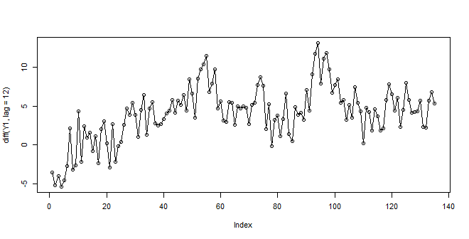

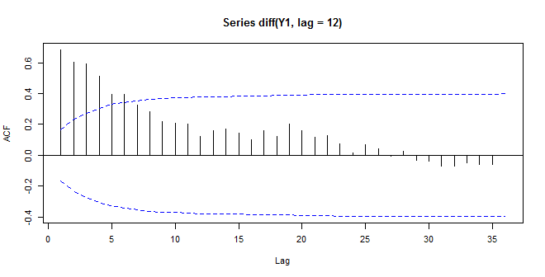

The series are the beginning has a different mean than the later index values. This indicates that it is not stationary. The ACF also doesn’t tapers off until after the 6th lag.

d) The following is a time series plot of both the first and twelfth difference of this time series and the sample ACF of the first and twelfth difference. Is the first and twelfth difference stationary? Justify your answer.

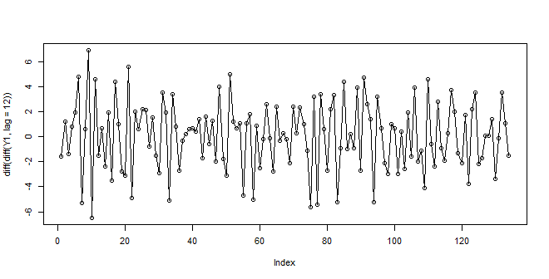

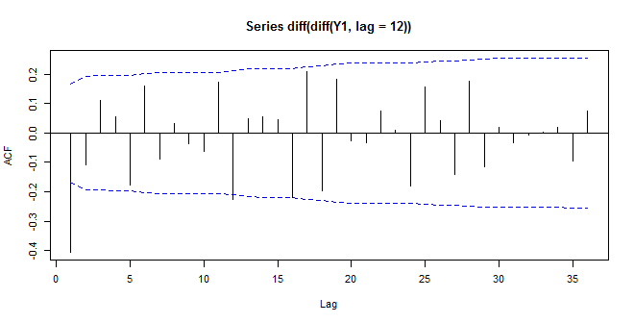

This does look stationary. The graph of the series has a constant mean and the variance is constant. The ACF tapers off after one lag.

e) The following is the sample PACF of the first and twelfth difference of this time series. Use all the plots that are available to postulate an ARIMA model for this data.

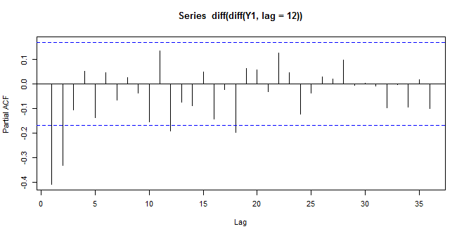

MA(1) because the ACF graph tapers off after 1 lag.

3a) The following is a time series plot of a seasonal time series and the sample ACF of the time series. Is this process stationary? Justify your answer.

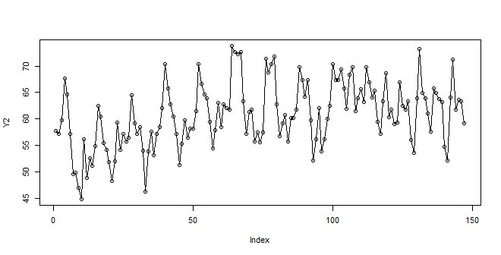

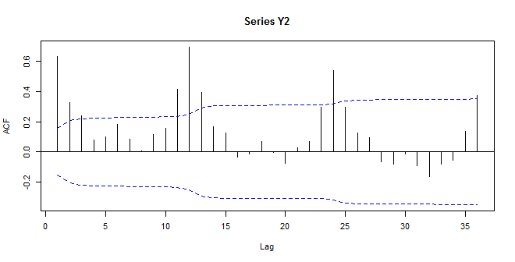

The first graph indicates that the mean is a litter higher in the beginning but overall indicates that it is stationary; however, the ACF indicates that it is a seasonal time series.

b) The following is a time series plot of the first difference of this time series and the sample ACF of the first difference of this time series. Is the first difference stationary? Justify your answer.

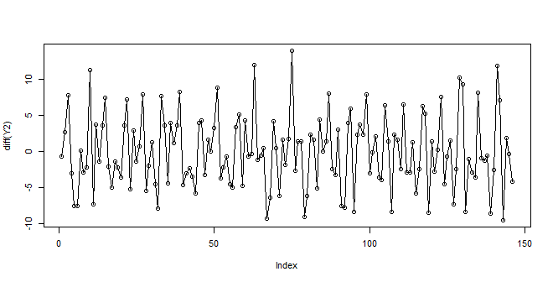

This graph does not indicate any issues. The mean and variance are constant.

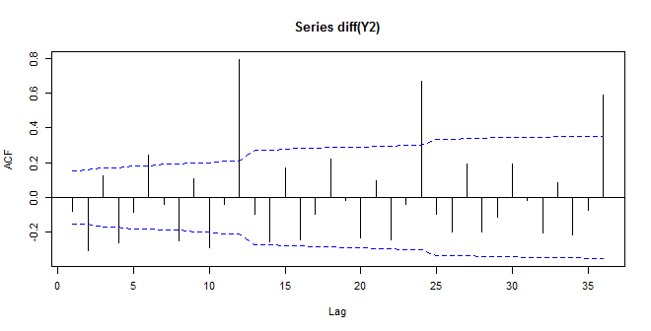

The ACF indicates that the graph is a seasonal time series because there are values outside of the lines at 12, 24, and 36.

c) The following is a time series plot of the twelfth difference of this time series and the sample ACF of the twelfth difference. Is the twelfth difference stationary? Justify your answer.

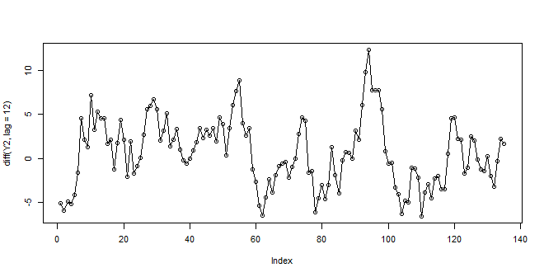

This graph indicates that the series is not stationary. The mean and variance are not constant.

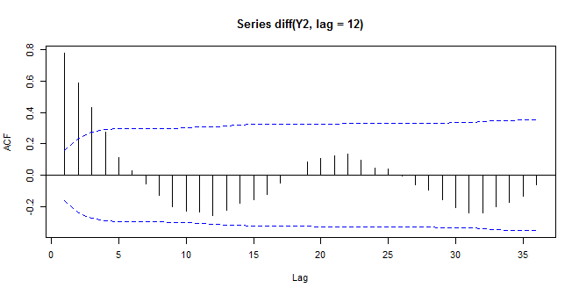

d) The following is the sample PACF of the twelfth difference of this time series. If it is assumed that the 12th difference is stationary, use the available plots to identify an ARIMA model for this time series.

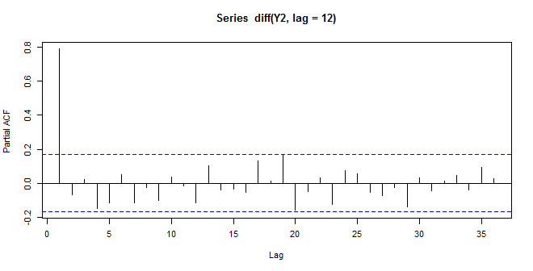

AR(1) seems appropriate because the PACF tapers off after one lag.